

Pirates/Under the Sea

**Nursery Topic Letter – Summer 2**

**Staff**

Mrs Box

Nursery Teacher

Mrs Caserta

Nursery Nurse

**Topic**

Our topic this half term is **‘Pirates and Under the Sea’.**

This term we will continue to focus on embedding and following the rules and routines of the Nursery day as well as beginning to prepare children for continuing these good habits into Reception. We will continue to develop our mark making, adding detail to our work and therefore more meaning to the marks that we make. We will continue to develop coordination and control within our fine and gross motor skills and focus on building strength and control in our dominant hand. In Maths we will be deepening our knowledge of numbers to 5, exploring night and day as a first introduction to time and consolidating learning from across the year. The stories that we will be focusing on are –

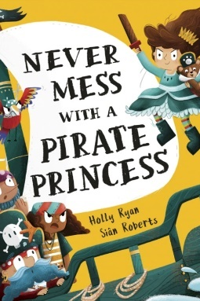

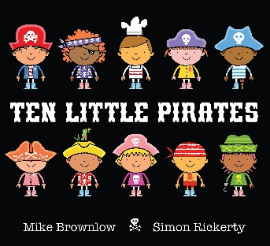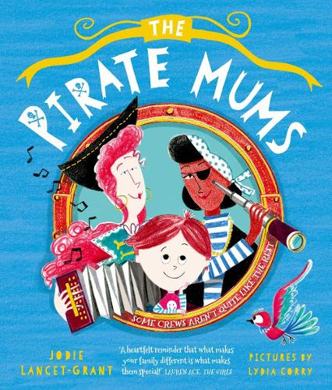

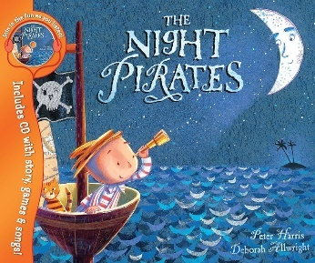



**Home Learning**

Homework/Home learning is not a requirement for Nursery children but please do keep an eye on Class Dojo as we may post some optional home learning activities for you to complete from time to time.

I will be sending all children home with a name writing pencil in the first week back. Please spend a few minutes each day helping your child to write their name. If they can already write their name then their next step is to focus on forming the letters correctly.

**Uniform**

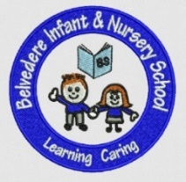Please ensure that your child is in the correct uniform and that **every** piece of your child’s uniform is **clearly named** so that we are able to identify any items that may get misplaced throughout the day. Long hair should be tied back in an effort to limit the spread of head lice and **jewellery must not be worn to school** for health and safety purposes. We have limited space within the classrooms to store backpacks and trolley cases so please ensure your child has a **book bag** that they bring to school every day.

**Physical Development**

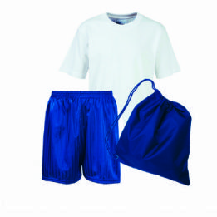Physical Development will be incorporated into our indoor and outdoor provision daily. As well as this, children will receive a weekly PE session with our PE teacher. Please keep an eye on Class Dojo where PE days will be announced.

**Birthday treats**

We are aware that some parents like to bring in a treat for the children in the class for their child's birthday.

We will no longer permit any food to be handed out on the school premises. This is due to allergies.

If you wish to bring in a treat it should not be food, an example could be pencils, rubbers, party bag type toys, or even a book for the class to share.

There is no obligation to bring in anything for your child's birthday.

**How Can You Help?**

* Sing songs, read and share stories with your child **every day**
* **Practise recognising and writing your child’s name daily –** Name writing cards will be sent home this term!
* Practise counting, recognising, representing and ordering numbers to 5 and beyond if able
* Share stories, non-fiction books, songs and rhymes and encourage your child to discuss what they have read or heard
* Practise dressing and undressing independently in preparation for PE lessons
* Practise putting on and zipping/buttoning coats independently
* Daily fine motor activities such as cutting, squeezing and threading will help strengthen the hand muscles in preparation for writing
* Check Class Dojo daily for updates and announcements

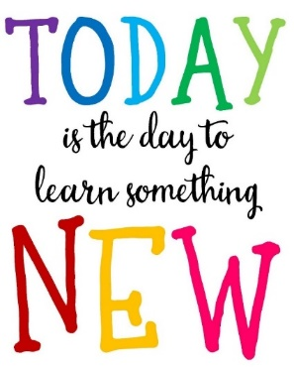

Thank you for your continued support,

Mrs Box and Mrs Caserta