**Year 1**

**Summer 2 Newsletter**

We hope you had a restful break and are ready for another exciting half-term in Year One. Our topic is ‘The Earth: Our Home’ and we will be comparing Belvedere to other locations as well as exploring animals and their different habitats.

**Topic – The Earth: Our Home**

Our topic this half term is ‘The Earth: Our Home’. The children will be learning all about the different groups of animals such as birds, reptiles, mammals and amphibians and will be using this knowledge to sort animals. We will be looking at different animal habitats around the world and how animals are adapted to live in different parts of the world. and what they need to grow. Linked to this, in Geography they will look at Belvedere and compare it with other locations in the UK and across the world.

**Maths**

In maths this half term, the children will continue to explore numbers from 50-100. We will continue to use their knowledge of number and apply this to problem and reasoning questions. Children will continue their maths learning on measurement (capacity, weight and length).

**Phonics/Reading**

Children will continue with their daily phonics sessions following the Little Wandle Scheme. As we have the phonics screening check coming up next week, children will revisit and revise previously taught sounds to consolidate their knowledge of these sounds. If you would like to read more about the phonics screening check, please visit: <https://assets.publishing.service.gov.uk/media/676e908e517edf5c74c83728/Phonics_screening_check_information_for_parents.pdf>

Our focus texts in our reading sessions this half-term are: ‘The Lion Inside’, ‘The Hare and the Tortoise’ and ‘The Proudest Blue’.

**English**

In writing, the children will be focussing on composing sentences using the correct grammar and punctuation. We will be having a big focus on spellings and handwriting especially as we will be preparing to get ready for our transition to Year 2 in September! Children will continue to explore pattern and rhyme in poetry and will be performing their rehearsed poem to an audience! We will also be revisiting instructional writing.

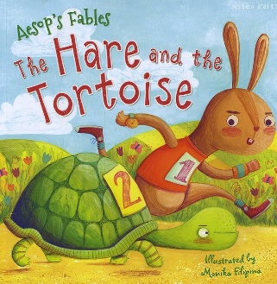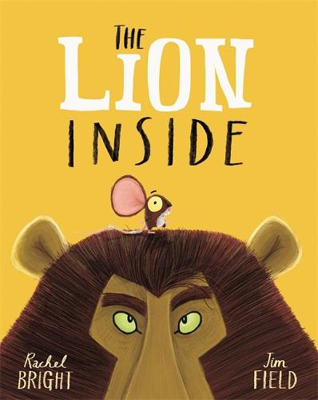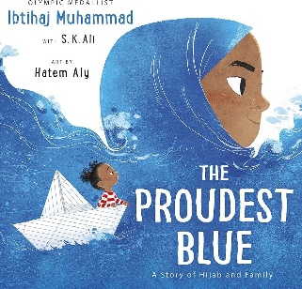

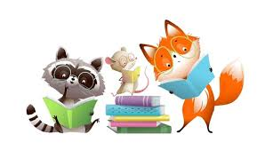

**Reminders:**

Please ensure that your child is in the correct uniform and that every piece of your child’s uniform is **clearly named** so that we can identify any items that may get misplaced. If there is no name, we cannot guarantee the item will be returned.

Earrings and jewellery **must not** be worn to school for health and safety purposes.

Please ensure children bring their book bag with their reading book and yellow reading record every day. When reading with your child, please write a short comment in the reading record.

**Important Dates**

School Trip to Mudchute Farm – Tuesday 17th June

Last day of term – Wednesday 23rd July



**Now the weather is getting warmer, please make sure children have a named water bottle and hat in their bag.**

**Homework**

Homework books will be sent home every Friday and are to be returned the following Wednesday. There will be a sheet containing all the homework for Summer 2. Each week, we would like the children to select one of the homework tasks and complete this in their homework books. You do not have to complete all of the homework provided , **just one per week** so that all are completed by the end of Summer 2.

**PE Days**

**Rubik:** Tuesday/Thursday

**Simmons**: Tuesday/Friday

**Franklin**: Monday/Tuesday

PE kits should include plain blue shorts or black/blue/grey tracksuit bottoms, a plain white t-shirt and plimsolls or trainers. Children should come to school dressed in their PE kit on PE days.