PE Funding

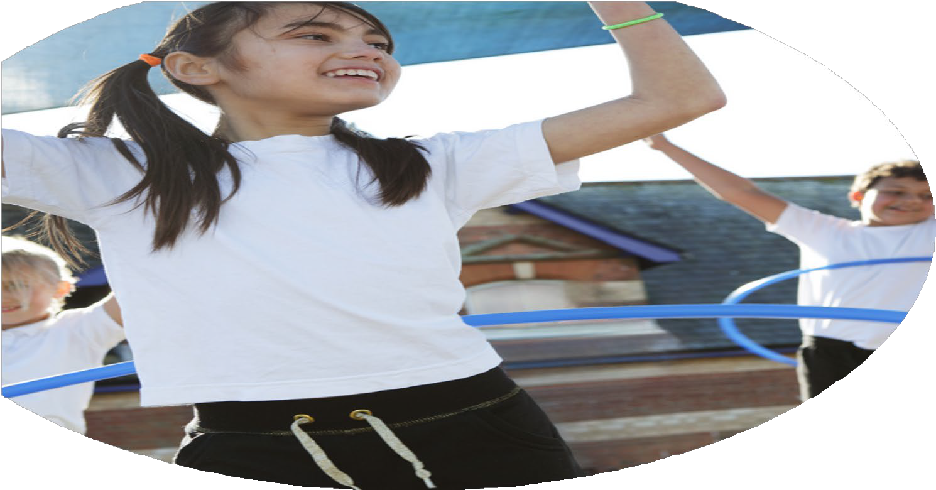

Evaluation Form

**Commissioned by**

**Created by**

Images courtesy of Youth Sport Trust

**PE Funding Evaluation Form**

 It is intended that this template should be used as preparation for the completion of the statutory digital reporting tool being introduced this academic year. You can upload data (including swimming) from this template onto this platform once it becomes accessible.

 Before you decide how you are going to use the funding for this academic year you should reflect and evaluate the impact of your use of the funding in 2023/24.

 All spending of the funding must conform with the terms outlined in the Conditions of Grant document.  The template is a working document that you can amend/update during the year.

 Based on your evaluation of last year’s funding you should decide what you intend to do this academic year, how you will do it, and what impact you expect it to have.

It is important that the funding is used effectively and based on your school’s needs.

 You must use the funding to make additional and sustainable improvements to the PE and sport in your school.  You must develop and add to the PESSPA activities that your school already offers.

*Summative digital reporting from June 2025 will continue to include swimming and water safety information therefore funding can be used to provide top-up lessons where necessary to ensure pupils meet national curriculum swimming requirements.*

**We recommend that you start by reflecting on the impact of current provision and reviewing your previous spend**

|  |  |  |  |
| --- | --- | --- | --- |
| What went well? | How do you know? | What didn’t go well? | How do you know? |
| * Targeted interventions meant that all children had equal opportunities to access all types of sports. * Introducing Play leaders has meant that activity levels across the school have risen to 70% of all children reaching 30 active minutes 5 days a week. * Pupil voice data has risen to 90% of all children enjoying PE. * 70% of KS1 have taken part in an Inter competition and 30% have had access to level 3 competition. | * Extracurricular tracker allowed us to effectively track participation levels and ensure that disadvantaged pupils had access to all sports & clubs. * Pupil voice surveys collected in December and July. Data has shown a huge increase in participation and enjoyment due to a shift in focus to holistic learning and celebrating the whole child. * We have competed in lots of competitions amongst our school and competitions in our local area. | * CPD- Our PE specialist is extremely confident in delivering high quality PE lessons in all sports. However not all teachers are confident in the delivery of high-quality PE lessons. * Not all children are active for 30 minutes a day. * Only 70% of children have taken part in level 2 competitions and 30% in level 3 competitions. | * Staff confidence levels visible in observations. Staff surveys also identify areas where staff are less confident. * Children participation tracker has allowed me to see the groups of inactive children. * Pupil trackers have shown competition data. Next year we will have a big push on competitions with 90%+ competing in level 2 competitions and 50% in level 3 competitions. |

|  |  |
| --- | --- |
| What are your plans for 2024/25? | How are you going to action and achieve these plans? |
| Intent | Implementation |
| * Ensure that all children are provided two hours of high-quality PE lessons by ensuring all teachers receive CPD in areas of which they are not confident in delivering. Areas identified by staff surveys. * Increase the number of children participating in level 2 and 3 competitions. * Continuing to invest in sports equipment has allowed us to increase the number of sports that children have available as well as ensuring we can host competitions of various levels with Inter school competitions as well as competitions amongst our local schools. * Continue to invest in high-quality planning, with PE Pro and AFPE memberships. * Lots of focus on play leader training giving children the opportunity to lead activities. * Increase the number of children accessing and completing 30 active minutes per day. | * Ensure that all suitable equipment is available to provide high- quality teaching and learning. * Specialists in to provide CPD to all members of staff on Inset Days. Specialists to complete lessons with less confident and less experienced teachers. * All members of staff are provided with PE Pro logins to allow staff to access high-quality planning and use all appropriate resources available. * PE leader to apply for as many sports competitions available to KS1 as possible. * Arrange inter school competitions amongst KS1 allowing all pupils to access competitive sports. * Arrange sporting competitions with fellow local primary schools. * Specialist training provided to Sports leaders to upskill and increase their confidence when leading activities. * Assessment of delivery ensuring that 70%+ can achieve 30 active minutes a day. * Work with staff to encourage active learning throughout the day. * Encourage the use of brain breaks which were a successful introduction last year. * Collaborate and provide ideas to parents/ carers of ways and activities to keep children active and encourage a positive relationship with exercise. |

|  |  |
| --- | --- |
| What impact/intended impact/sustainability are you  expecting? | How will you know? What **evidence** do you have or  expect to have? |
| * Increased number of children accessing and completing 30 active minutes per day. * We predict that 80-90% of children will complete 30 active minutes per day, 7 days per week. * We hope by increasing staff confidence in delivering PE pupils enjoyment levels increase and encourages children to complete 30 active minutes per day. * Increase the number of children participating in level 1 and 2 competitions. * Introducing inter school and competitions between local schools we hope to increase the number of children participating. * Continue growing our sports leader program working with Belvedere junior school. * Encouraging pupils to lead activities and maintain a positive relationship with sport. * Encourage access to a range of sports and activities appealing to all children ensuring all children are able to access these activities. | * Pupil voice surveys will show enjoyment levels. * Pupil participation tracker will show children accessing and completing 30 active minutes. * External activity trackers to be completed at home by children and family members tracking their activities throughout their time outside of school. * Competition application forms. * Pupil voice surveys. * Competition registers. * Increased number of sports leaders leading activities. * Participation registers. * Pupil voice surveys. |

|  |  |
| --- | --- |
| What **impact/sustainability** have you seen? | What **evidence** do you have? |
| * We have tracked all participation in activity for our pupils and our data has shown a 15% increase in pupils reaching 30 minutes of physical activity per day. This has been achieved as all pupil’s access two hours of PE per week, we have a huge focus on structured active play activities, we have also implemented a range of afterschool sports clubs. * We have entered various competitions this year competing in inter and intra school competitions. * We have completed staff surveys and staff confidence in delivering PE has increased, we have ensured this is the case by providing staff with various CPD opportunities. (Staff meetings, PE pro day, PE lead providing paired teaching sessions, ECT’s completed observations on PE lead, Charlton Athletic Primary Stars have worked with ECT’s providing CPD over a 6 week course.) * The number of children participating in inter school competitions is 100%. * The number of children participating in intra school competitions has risen by 10%. * This year in collaboration with Belvedere Junior School we have successfully trained 42 play leaders to deliver active play sessions and activities to KS1 and EYFS. * We have introduced new sports such as Baseball, American football and Lacrosse. | * Competition & club registers * Pupil activity trackers * Pupil Voice surveys * Teacher voice surveys * Primary stars forms * Pupil voice * Staff meeting attendance registers * Participation registers * Competition photos * Social Media posts * Pupil voice * Pupil voice * Training certificates * Photos * Participation tracker |